Manual Test Plan – Week 4

Auto-Constraints

The buttons on the bottom of the iPhone 5 screen should be at the bottom of the smaller iPhone screens

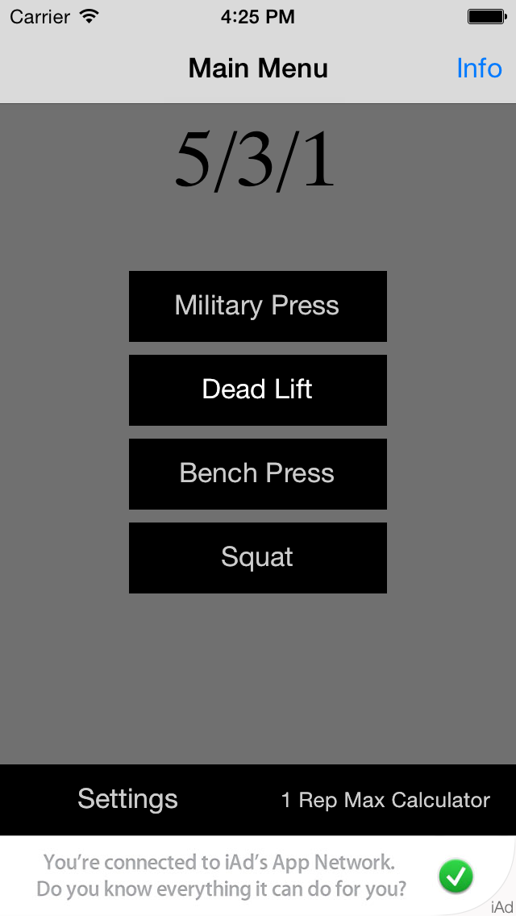Incorrect Correct

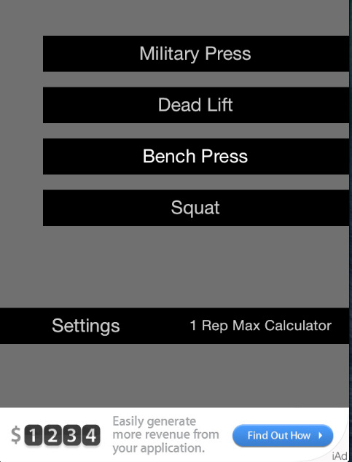

Nothing should overlap for either size iPhone

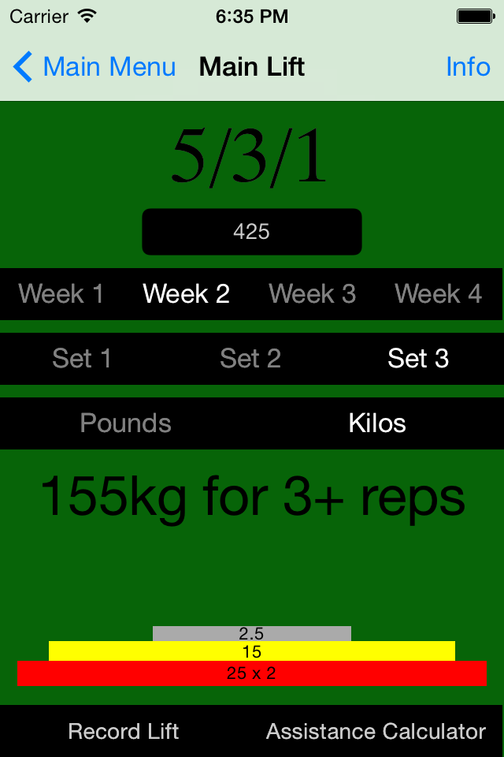

Unit Conversation

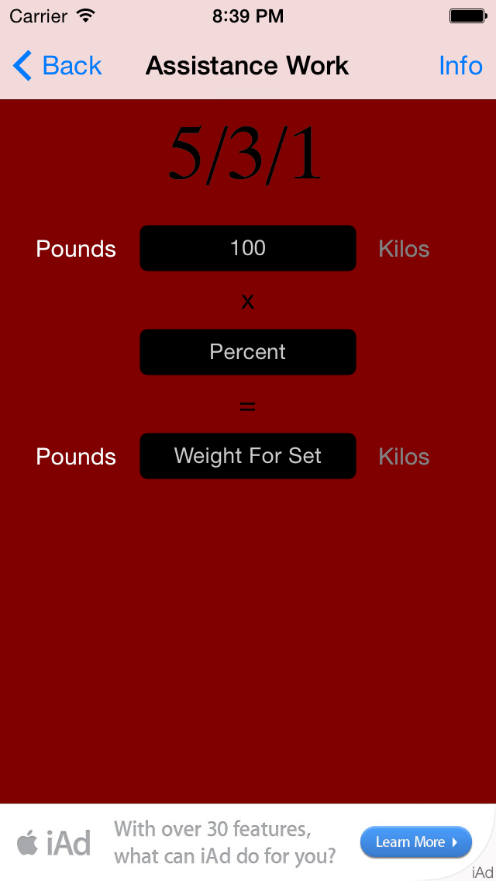Switching between units in the assistance or 1RM calculator should keep the same two weights

